**Software Testing Assignment**

**Module–1(Fundamental)**

**• What is SDLC?**

Software Development Life Cycle is a series of steps that provides model for development and life cycle of a software.

It includes below mentioned Phases:

1. Requirements
2. Analysis
3. Design
4. Implementation
5. Testing
6. Deployment
7. Maintenance

**• What is software testing?**

Testing is the process of evaluating a system or itscomponent(s) to determine whether it satisfies the specified requirements

**• What is agile methodology?**

Agile methodology is delivering a working software divided into small parts with continues feedback and improvement. It is iterative and incremental model process model.

**• What is SRS?**

SRS is software requirement specification document. It is complete description of the behaviour of a software to be developed. It includes functional and non-functional requirements.

**• What is oops?**

Object Oriented Programs

It is a way to write a code, it has less redundancy, and reusability, it is secure to use

**• Write Basic Concepts of oops**

Concepts of OOPs:

1. Class
2. Objects
3. Inheritance
4. Encapsulation
5. Polymorphism
6. Abstraction

**• What is object?**

Object gives permission to access functionality of class.

**• What is class?**

Class is a collection of data member and member function.

**• What is encapsulation?**

Encapsulation is wrapping of data

**• What is inheritance?**

It is to derive attribute of some other class

**• What is polymorphism?**

One task performed in many ways

**• Draw Use case on online bill payment system (Paytm)**

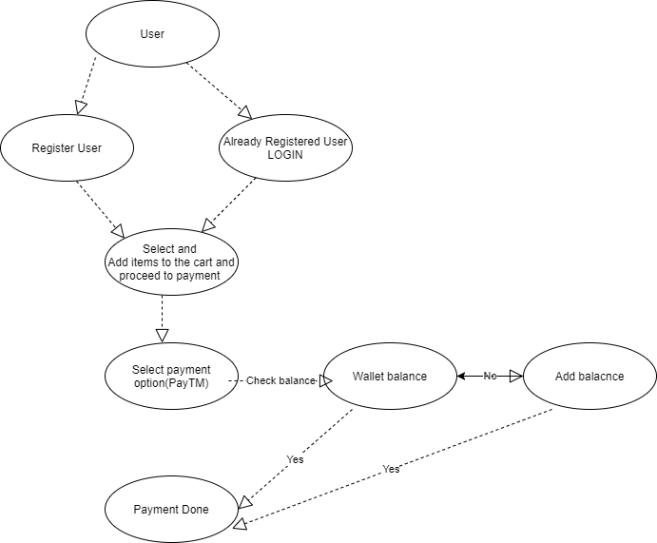

**• Draw Usecase on banking system for customers.**

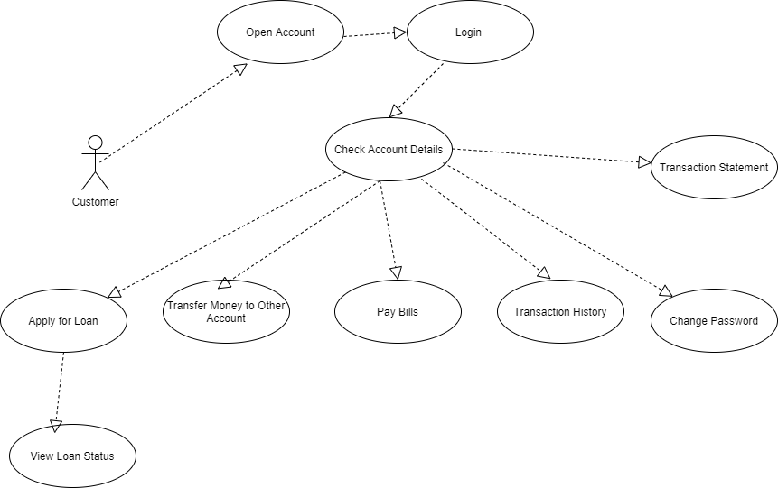

**• Draw Usecase on Broadcasting System.**

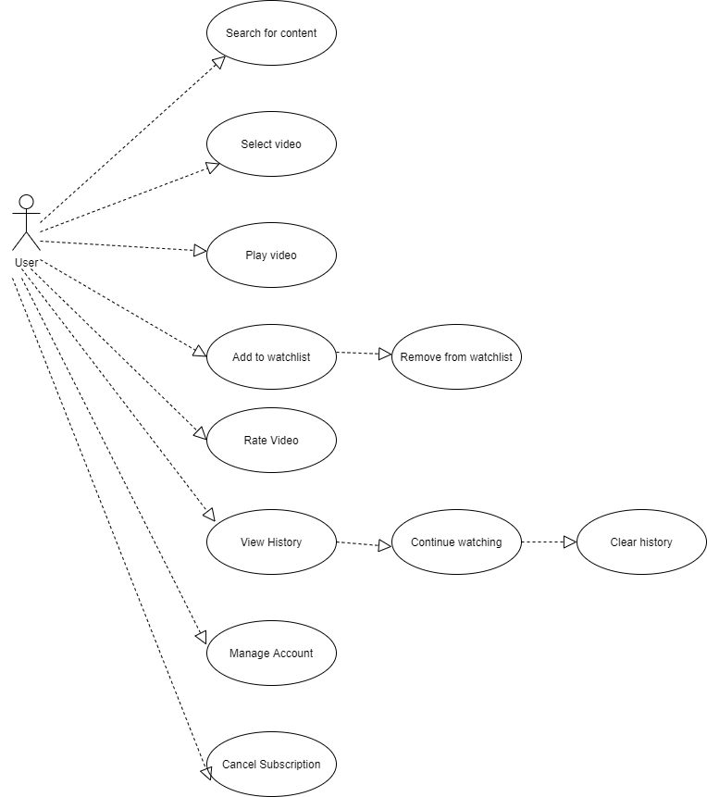

**• Write SDLC phases with basic introduction**

SDLC phases are

1. Requirement
2. Analysis
3. Design
4. Implementation
5. Testing
6. Deployment
7. Maintenance
8. Requirement: Gathers requirements from the customer and prepare requirement document
9. Analysis: Requirement analysis is done in this phase with understanding of requirements of customers
10. Design: Architecture Design of a project is done in this phase, Test plan is also generated in this phase depending upon the scenarios
11. Implementation: Development phase
12. Testing: Testing is done in this process depending upon the methodology which is being used for the system
13. Deployment: Delivering a software to the customer after testing phase is done
14. Maintenance: maintenance needs to be done after deployment of the system

**• Explain Phases of the waterfall model**

Waterfall model is having below mentioned phases:

1. Requirement gathering and analysis: Requirements gathered from the customer and documented and analysed, once SRS is frozen than only, we can move to next phase
2. Design: in this phase high level design of a software is generated on the basis of SRS
3. Implementation: it is a coding phase
4. Testing and deployment: Testing of a software is done once the code is submitted and unit testing is done by developers. And after testing is done deployment of a software is done to end user
5. Maintenance: Once product is delivered to the customer maintenance needs to be done

**• Write phases of spiral model**

Phases of spiral model:

1. Planning
2. Risk Analysis
3. Engineering/development
4. Customer evaluation

• **Write agile manifesto principles**

Agile Principles:

1. Customer satisfaction through early and continuous delivery of a working product
2. Accommodate changing requirements throughout development
3. Frequent delivery of working software
4. Face to Face interaction ass there are daily meetings
5. Support, motivate team members
6. Collaboration between stakeholders and development team throughout the project
7. Simplicity
8. Regular reflection on how to become more effective
9. Attention to technical detail and design

• **Explain working methodology of agile model and also write pros and cons.**

Agile means delivering a working software in small parts with continuous feedback and improvements. It is based on iterative – incremental model.

Pros:

1. Quick delivery
2. Accommodate requirements throughout the development
3. Customer involvement throughout the project
4. Work divided into small parts
5. Continuous testing and feedback

Cons:

1. Minimum documentation is done
2. Depends on continue customer interaction

**• Draw Usecase on OTT Platform.**

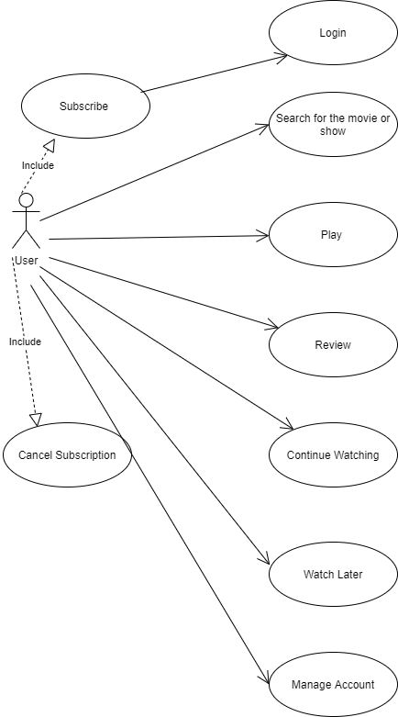

**• Draw usecase on E-commerce application**

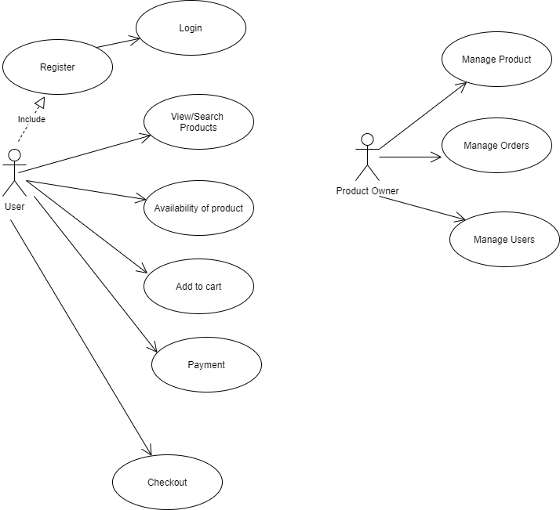

**• Draw usecase on Online shopping product using payment gateway.**

